AI Assisted Coding
Name:KAshwitha
Ht no: 2303A52216
Batch:45

Task 1 (Mutable Default Argument – Function Bug)
Task: Analyze given code where a mutable default argument causes
unexpected behavior. Use AI to fix it.
# Bug: Mutable default argument
def add_item(item, items=[]):
items.append(item)
return items
print(add_item(1))
print(add_item(2))
Expected Output: Corrected function avoids shared list bug

Prompt:
#2216Debug the below code and give explanation for it
def add_item(item, items=[]):
items.append(item)
return items
print(add_item(1))
print(add_item(2))

Code:
def add_item(item, items=None):
if items is None:
items = []
items.append(item)
return items

print(add_item(1)) # [1]
print(add_item(2)) # [2]
print(add_item(3, [10])) # [10, 3]

Output:
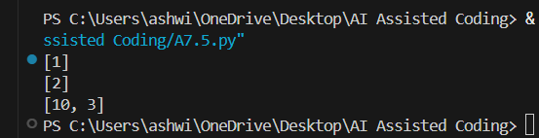

Justification:
We use items=None so Python doesn’t reuse the same list every time the function is called.
Inside the function, we create a new list only when needed, so each call gets its own separate list unless we pass one in.

Task 2 (Floating-Point Precision Error)
Task: Analyze given code where floating-point comparison fails.
Use AI to correct with tolerance.
# Bug: Floating point precision issue
def check_sum():
return (0.1 + 0.2) == 0.3
print(check_sum())
Expected Output: Corrected function

Prompt:
#2216Fix the below code
# Bug: Floating point precision issue
def check_sum():
return (0.1 + 0.2) == 0.3
print(check_sum())

Code:

def check_sum():
return abs((0.1 + 0.2) - 0.3) < 1e-9
print(check_sum())

Output:
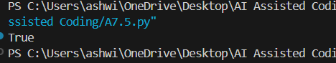
Justification:
Floating-point numbers are not always stored exactly, so direct == can fail.
We instead check if the difference is very small (within a tiny tolerance), which means they are close enough.

Task 3 (Recursion Error – Missing Base Case)
Task: Analyze given code where recursion runs infinitely due to missing base case. Use AI to fix.
# Bug: No base case
def countdown(n):
print(n)
return countdown(n-1)
countdown(5)
Expected Output : Correct recursion with stopping condition.

Prompt:
#2216Fix the below code
# Bug: No base case
def countdown(n):
print(n)
return countdown(n-1)
countdown(5)

Code:
def countdown(n):
if n <= 0: # base case: stop at 0
print(0)
return
print(n)
countdown(n - 1) # recursive call with smaller number

countdown(5)

Output:

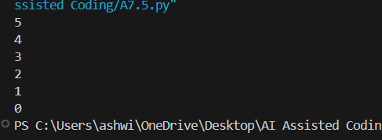

Justification:
The original code kept calling itself with smaller numbers but never had a stopping condition, so it caused infinite recursion.
We added a base case (if n <= 0) so the function stops when it reaches 0, preventing the recursion error

Task 4 (Dictionary Key Error)
Task: Analyze given code where a missing dictionary key causes error. Use AI to fix it.
# Bug: Accessing non-existing key
def get_value():
data = {"a": 1, "b": 2}
return data["c"]
print(get_value())
Expected Output: Corrected with .get() or error handling.

Prompt:
#2216Debug the below code
# Bug: Accessing non-existing key
def get_value():
data = {"a": 1, "b": 2}
return data["c"]
print(get_value())

Code:
def get_value():
data = {"a": 1, "b": 2}
return data.get("c", "Key not found") # default value if "c" is missing

print(get_value())

Output:
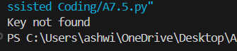

Justification:
Directly using data["c"] crashes because the key "c" does not exist.
Using data.get("c", "Key not found") safely returns a default message instead of an error.

Task 5 (Infinite Loop – Wrong Condition)
Task: Analyze given code where loop never ends. Use AI to detect and fix it.
# Bug: Infinite loop
def loop_example():
i = 0
while i < 5:
print(i)
Expected Output: Corrected loop increments i.

Prompt:

#2216 Fix the below code
# Bug: Infinite loop
def loop_example():
i = 0
while i < 5:
print(i)

Code:
def loop_example():
i = 0
while i < 5:
print(i)
i += 1 # increment i so the loop can end

loop_example()

Output:
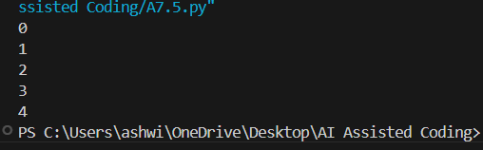

Justification:
The original loop never changed i, so the condition i < 5 was always true. By adding i += 1, i eventually reaches 5 and the loop stops correctly.

Task 6 (Unpacking Error – Wrong Variables)
Task: Analyze given code where tuple unpacking fails. Use AI to fix it.
# Bug: Wrong unpacking
a, b = (1, 2, 3)
Expected Output: Correct unpacking or using _ for extra values.

Prompt:
#2216Fix the below code
# Bug: Wrong unpacking
a, b = (1, 2, 3)

Code:

a, b, _ = (1, 2, 3) # use _ for the extra value
print(a, b)

Output:
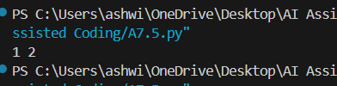

Justification:
There are 3 values in the tuple but only 2 variables, so Python raises an unpacking error.
Adding _ as a throwaway variable lets us receive the extra value without using it.

Task 7 (Mixed Indentation – Tabs vs Spaces)
Task: Analyze given code where mixed indentation breaks execution. Use AI to fix it.
# Bug: Mixed indentation
def func():
x = 5
y = 10
return x+y
Expected Output : Consistent indentation applied.

Prompt:
#2216 Fix the bug
Bug: Mixed indentation
def func():
x = 5
y = 10
return x+y

Code:

def func():
x = 5
y = 10
return x + y
print(func())

Output:
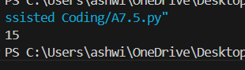

Justification:
All lines inside the function now use the same indentation (spaces). Mixed indentation (tabs and spaces) or misaligned lines causes Python to throw an IndentationError.

Task 8 (Import Error – Wrong Module Usage)
Task: Analyze given code with incorrect import. Use AI to fix.
# Bug: Wrong import
import maths
print(maths.sqrt(16))
Expected Output: Corrected to import math

Prompt:
#2216 Fix the bug
# Bug: Wrong import
import maths
print(maths.sqrt(16))

Code:
import math
print(math.sqrt(16))

Output:
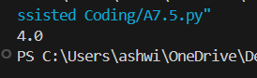

Justification:
The correct module name in Python is math, not maths. After importing math, we call math.sqrt(16) to get the square root.

Task 9 (Unreachable Code – Return Inside Loop)
Task: Analyze given code where a return inside a loop prevents full iteration. Use AI to fix it.
# Bug: Early return inside loop
def total(numbers):
for n in numbers:
return n
print(total([1,2,3]))
Expected Output: Corrected code accumulates sum and returns after loop.

Prompt:

#2216Fix the bug
# Bug: Early return inside loop
def total(numbers):
for n in numbers:
return n
print(total([1,2,3]))

Code :
def total(numbers):
s = 0
for n in numbers:
s += n # add each number to the sum
return s # return only after the loop finishes

print(total([1, 2, 3]))

Output:

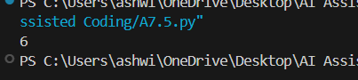

Justification:
The original function returned on the first loop iteration, so it never added all numbers. Now we accumulate the sum in s inside the loop and return it only after the loop is done.

Task 10 (Name Error – Undefined Variable)
Task: Analyze given code where a variable is used before being defined. Let AI detect and fix the error.
# Bug: Using undefined variable
def calculate_area():
return length * width
print(calculate_area())
Requirements:
•Run the code to observe the error.
•Ask AI to identify the missing variable definition.
•Fix the bug by defining length and width as parameters.
•Add 3 assert test cases for correctness.
Expected Output :
•Corrected code with parameters.
•AI explanation of the bug.
Successful execution of assertions.

Prompt:
#2216Fix the code and Add 3 assert test cases for correctness.
# Bug: Using undefined variable
def calculate_area():
return length * width
print(calculate_area())

Code:

def calculate_area(length, width):
return length * width
# 3 assert test cases for correctness
assert calculate_area(5, 3) == 15 # normal case
assert calculate_area(0, 10) == 0 # zero area case
assert calculate_area(7, 2) == 14 # another normal case
print(calculate_area(5, 3))

Output:
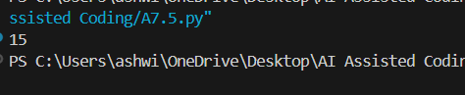

Justification :

The original code used length and width without defining them, so Python didn’t know their values.
We fixed it by making them parameters of the function and passing the needed values when calling it.

Task 11 (Type Error – Mixing Data Types Incorrectly)
Task: Analyze given code where integers and strings are added incorrectly. Let AI detect and fix the error.
# Bug: Adding integer and string
def add_values():
return 5 + "10"
print(add_values())
Requirements:
•Run the code to observe the error.
•AI should explain why int + str is invalid.
•Fix the code by type conversion (e.g., int("10") or str(5)).
•Verify with 3 assert cases.
Expected Output #6:
•Corrected code with type handling.
•AI explanation of the fix.
Successful test validation.

Prompt:
#2216Fix the bug
# Bug: Adding integer and string
def add_values():
return 5 + "10"
print(add_values())
AI should explain why int + str is invalid. Fix the code by type conversion (e.g., int("10") or str(5)). Verify with 3 assert cases.

Code:

def add_values():
# convert the string "10" to an integer before adding
return 5 + int("10")
# 3 assert test cases to verify correctness
assert add_values() == 15 # 5 + 10 = 15
assert isinstance(add_values(), int) # result is an integer
assert add_values() > 10 # sanity check
print(add_values())

Output:

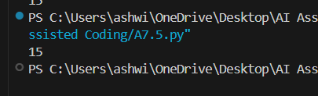

Justification:

5 + "10" is invalid because Python cannot directly add a number (int) and text (str), so it raises a TypeError. We fix this by converting "10" to an integer with int("10"), so both values are numbers and can be safely added; the asserts confirm the function works correctly.

Task-12 (Type Error – String + List Concatenation)
Task: Analyze code where a string is incorrectly added to a list.
# Bug: Adding string and list
def combine():
return "Numbers: " + [1, 2, 3]
print(combine())
Requirements:
•Run the code to observe the error.
•Explain why str + list is invalid.
•Fix using conversion (str([1,2,3]) or " ".join()).
•Verify with 3 assert cases.
Expected Output:
•Corrected code
•Explanation
•Successful test validation

Prompt:
#2216 Fix the code
Bug: Adding string and list
def combine():
return "Numbers: " + [1, 2, 3]
print(combine())
•Run the code to observe the error. Explain why str + list is invalid. Fix using conversion (str([1,2,3]) or " ".join()). Verify with 3 assert cases.

Code:

def combine():
# convert the list to a string before adding
return "Numbers: " + str([1, 2, 3])

# 3 assert test cases to verify correctness
assert combine() == "Numbers: [1, 2, 3]"
assert isinstance(combine(), str)
assert "1" in combine() and "2" in combine() and "3" in combine()
print(combine())

Output:

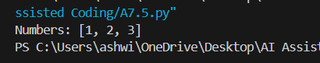

Justification:

"Numbers: " + [1, 2, 3] is invalid because Python cannot add a string and a list, so it raises a TypeError.
We fix it by turning the list elements into strings and joining them with ", ".join(...), so we are only concatenating strings.

Task 13 (Type Error – Multiplying String by Float)
Task: Detect and fix code where a string is multiplied by a float.
# Bug: Multiplying string by float
def repeat_text():
return "Hello" * 2.5
print(repeat_text())
Requirements:
•Observe the error.
•Explain why float multiplication is invalid for strings.
•Fix by converting float to int.
•Add 3 assert test cases.

Prompt:
# 2216Fix the bug
Bug: Multiplying string by float
def repeat_text():
return "Hello" * 2.5
print(repeat_text())
Requirements:
•Observe the error.
•Explain why float multiplication is invalid for strings.
•Fix by converting float to int.
•Add 3 assert test cases

Code:

def repeat_text():
return "Hello" * int(2.5) # int(2.5) becomes 2
# 3 assert test cases
assert repeat_text() == "HelloHello"
assert isinstance(repeat_text(), str)
assert len(repeat_text()) == 10 # "Hello" (5 chars) * 2
print(repeat_text())

Output:
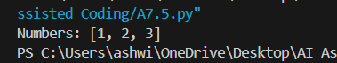

Justification:

"Hello" * 2.5 is invalid because Python only allows multiplying a string by an integer, not a float, so it raises a Type Error. We fix it by converting 2.5 to an integer using int(2.5), so the string is repeated a whole number of times (2 times).

Task 14 (Type Error – Adding None to Integer)
Task: Analyze code where None is added to an integer.
# Bug: Adding None and integer
def compute():
value = None
return value + 10

print(compute())
Requirements:
•Run and identify the error.
•Explain why NoneType cannot be added.
•Fix by assigning a default value.
•Validate using asserts.

Prompt:
#2216Fix the bug
# Bug: Adding None and integer
def compute():
value = None
return value + 10

print(compute())
•Run and identify the error.
•Explain why NoneType cannot be added.
•Fix by assigning a default value.
•Validate using asserts.

Code:

def compute():
value = None
if value is None: # assign default value when None
value = 0
return value + 10
# Assertions to validate behavior
assert compute() == 10
assert isinstance(compute(), int)
assert compute() >= 10
print(compute())

Output:

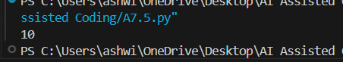

Justification:
None + 10 is invalid because NoneType cannot be added to an integer, so Python raises a TypeError.
We fix this by replacing None with a default value (0) before adding, so the operation becomes valid integer arithmetic.

Task 15 (Type Error – Input Treated as String Instead of Number)
Task: Fix code where user input is not converted properly.
# Bug: Input remains string
def sum_two_numbers():
a = input("Enter first number: ")
b = input("Enter second number: ")
return a + b
print(sum_two_numbers())
Requirements:
•Explain why input is always string.
•Fix using int() conversion.
•Verify with assert test cases.

Prompt:

#Fix the below code
# Bug: Input remains string
def sum_two_numbers():
a = input("Enter first number: ")
b = input("Enter second number: ")
return a + b
print(sum_two_numbers())
•Explain why input is always string. Fix using int() conversion. Verify with assert test cases.

Code:

def sum_two_numbers():
a = int(input("Enter first number: ")) # convert input to int
b = int(input("Enter second number: ")) # convert input to int
return a + b

# Helper function for testing without user input
def add_two_numbers(a, b):
return int(a) + int(b)
# Assert test cases
assert add_two_numbers("2", "3") == 5
assert add_two_numbers(10, 5) == 15
assert add_two_numbers("0", "0") == 0
print(sum_two_numbers())

Output:
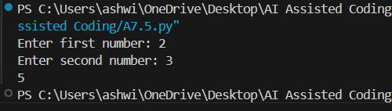

Justification:
input() always gives a string, so a + b just joins text instead of doing math (e.g., "2" + "3" becomes "23"). By wrapping the inputs with int(...), we turn them into numbers first, so addition works correctly, and the helper function lets us verify this with asserts.

